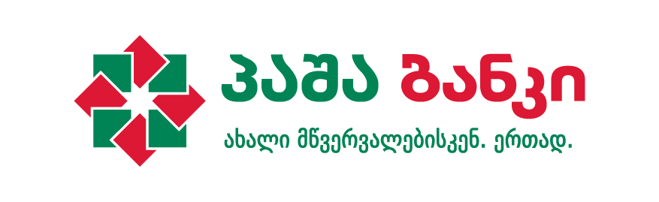

**PASHA Bank Sponsors Bond Congress**

# On June 16-17th the XIII CIS, Baltic States and Caucasus Bond Congress was held in Tbilisi, Radisson Blu Iveria. The congress was sponsored by PASHA Bank – a regional financial institution that provides a full range of corporate and investment banking services to large and medium-sized enterprises in the region.

Being held since 2004 the congress is a major event for the region, which supports discussions on the development of local bond markets in Russia, CIS and Caucasus countries, as well as Eurobonds’ emerging markets and other essential topics.   
  
Among the speakers there were: Archil Mestvirishvili - Vice President at National Bank of Georgia, Nikoloz Gagua - Deputy Minister at Ministry of Economy of Georgia, Archil Gachechiladze - Chairman at Galt & Taggart, Ivan Uhlianytsia - Director of Investment Banking at PASHA Bank Azerbaijan,Shahin Mammadov - CEO and Chairman of Board of Directors at PASHA Bank Georgia.

“We are happy that this year Tbilisi was chosen to host the Bond Congress and PASHA Bank had the opportunity to actively participate in the event. PASHA Bank has a significant experience in investment banking services in the region. Recently we have had successful cases of bond issuance in Georgia as well. We hope that this congress will serve the development of finance sector in our region.” – Said Shahin Mammadov, CEO and Chairman of Board of Directors at PASHA Bank Georgia.

The Bond Congress was attended by more than 150 representatives of local and international finance sectors. The event was organized by CBonds and was hosted by “Galt & Taggart”.